Message from Mrs Hird
Thank you all for your support and hard work in encouraging your children with their learning during this strange half term. We will be back with our blended learning offer from Monday 22nd February and will await further direction from the government with regards to full reopening.

This week, we have welcomed Clare Robinson to the team working at Breakfast Club.

I hope you and your family have a happy and healthy half term break.
Mrs Hird
Message from the Governing Body
We hope this Newsletter finds you all safe and well as we reach the half term break.

The announcement at the beginning of January about partial school closures presented the staff of our schools with a huge challenge as they were given a matter of hours to arrange and implement the delivery of both in-school and at-home learning. We are sure you will join us in thanking our staff for how quickly they adapted and the incredible efforts and hard work they have put into delivering the very best possible experiences for our children over the last six weeks. We are also very aware of the immense pressure the announcement put on our families who were also expected to make arrangements and adapt with very little notice. The wellbeing of our whole school communities - pupils, families and staff - is of paramount importance to us as a governing body and to the Yorkshire Endeavour Academy Trust and we sincerely hope that you and your children feel well supported by the schools.

As you know, the earliest date for a reopening of schools in England is currently 8th March and so, until that time and perhaps beyond, the school will continue to provide both remote and in-school learning. Your feedback on how you have found this so far is therefore very important and once the responses have been collated from the recent parent and pupil surveys, the governing body will review the insight these provide and will work to monitor how suggestions for improvement are being taken on board and how any issues raised are being addressed.

Although we have not been able to carry out in-person visits over this last half-term, we have worked with the staff across the three schools to ensure that monitoring activities have still gone ahead to schedule. As part of this, it has been fantastic to see and hear about examples of the three schools working so closely together - this clearly has a hugely positive impact on efficiency and on the quality of teaching and learning.

We currently have a vacancy on the board for a co-opted governor. We are looking for someone for this position who is a not a parent of a current pupil at any of the three schools and a recent skills audit has indicated that the board (and therefore the schools) would benefit from further expertise in HR and finance. Please think of anyone you know who may be suited to this and who would be passionate about contributing to the education of the young people in our community - good governance is an integral part of a successful school. Further information about the role of a governor can be found on our website: https://www.castletonprimaryschool.co.uk/about-our-school/our-governors/the-governor-role/

IMPORTANT - Positive Covid Tests
If your child has been attending school and tests positive for covid during the school holidays, please can you inform Mrs Hird by email at: headteacher.cg@yeat.co.uk in line with the guidance below. You will also need to follow the government guidance with regards to household isolation.

Any other children who have been in school on the same day(s) will also need to isolate for 10 days as a close contact and you will be advised of this by the school.

Close contacts are taken from 2 days before the person develops symptoms or (if there are no symptoms) tests positive. Therefore, if your child develops symptoms within two days of attending school, you will need to inform Mrs Hird, even if their positive test result doesn't come through until later in the week.
Day | Thursday | Friday | Saturday | Sunday | Action required
Situation 1 | Child attends school | Child absent |  |  | Inform Mrs Hird as soon as the positive test is confirmed.
 | Child develops Covid symptoms and subsequently tests positive

Day | Thursday | Friday | Saturday | Sunday | Action required
Situation 2 | Child attends school | Child attends school |  |  | Inform Mrs Hird as soon as the positive test is confirmed.
 | Child develops Covid symptoms and subsequently tests positive

Day | Thursday | Friday | Saturday | Sunday | Action required
Situation 3 | Child absent | Child attends school |  |  | Inform Mrs Hird as soon as the positive test is confirmed.
 |  | Child develops Covid symptoms and subsequently tests positive

If your child develops symptoms on Monday or later, you do not need to inform Mrs Hird but will need to follow government guidance.
News from the Classes
All of the Acorns were home learning for the first part of the week, due to the weather playing tricks on us. But as we are all getting so good at accessing either Class Dojo or Tapestry now, at least we can all see each other in our Zoom meetings and be doing the same activities.

In English, we have been writing postcards and diary entries from the Snail and the Whale characters and we have been delighted to see that everyone has tried so hard to use their new skills in their sentence writing. We have had adventurous adjectives, amazing adverbs, list sentences, conjunctions, time connectives, interesting sentence starters, exclamation marks, question marks, apostrophes and inverted commas - all squished onto the back of a postcard!
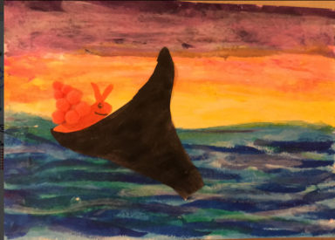
In Maths, everyone has done really well to complete their practical activities, their written activities and often their challenge activities to really stretch their (and their grown-ups’) deeper understanding of the concept. Well done, we are really proud of you all.
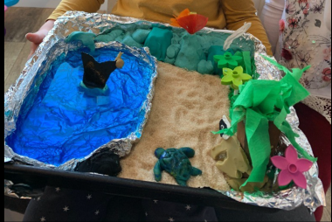
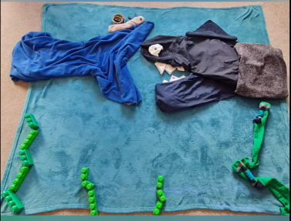
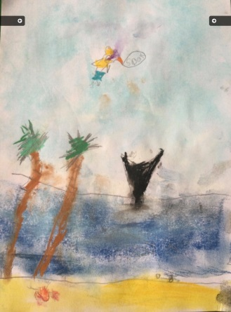
The Art task this week was to re-produce a favourite scene from the Snail and The Whale in whatever medium was preferred, and my goodness, we certainly had some amazing results! Some people drew and painted the most beautiful scenes, some made lovely collages, some made annotated photo films with sound effects and some made 3D scenes with real sand and water and scenery from all sorts of materials. We have been so delighted with how much effort and fun went into making them.

We were delighted to see some lovely photographs of you carrying out your Wellbeing Wednesday activities, a lot of which involved the snow, and your happiness was obvious in your big smiling faces.

This week we would like to say a big THANK YOU to all of the children and their parents for the huge effort that you have put into this half term. This lockdown been very challenging in so many ways, but you have all been so hard working and supportive of the home learning and of us as well. We all teach because we love to work with children,
and it is really sad and challenging when we can't be with them but with everyone pulling together, we have managed to keep up the contact and communication and hopefully not feel so detached this time around.
Everyone deserves to be Stars of the half term, but we do have two Stars of the Week: Robyn for continuing to produce a very high standard of work at home, for challenging herself and extending her activities and for keeping Dad on track with the SPAG activities - well done Robyn.
We also have Scarlett, who has worked really hard at home, in all of her subjects; she has produced some especially descriptive writing, remembering all of the techniques that we have covered in our lessons. Well done Scarlett.

For the last week of this half term, the Oaks have continued working hard on their Dojo tasks. In maths, multiplication and division has been continuing in Year 3/4 and decimals have begun in Year 5/6. The children have been exploring, performing and composing poems with rhyme. They have even managed to create a poem linked to the High Rise Mystery tower block. There have been some great dance moves as the children continue to work through the street dance routine among the photos of fun in the snow.

Mrs Walley has been so pleased with the effort, determination and resilience the children have shown this half term in completing their tasks and turning up for the Zoom learning too. This has only been possible with your added support and encouragement on a daily basis. So well done to the children and the home schooling parents! All enjoy a well-deserved break and rest over the holidays.
The in school star of the week this week is Ned for working hard to complete all of his tasks to show his full potential.
The home school star of the week this week is Jocelyn always working hard at home and giving good answers during the Zooms.

Can you Walk “Coast to Coast”? (Virtually!!)
Can you walk 190 miles – the total distance of the Coast to Coast Walk from St Bees to Robin Hood’s Bay – starting on 14th February and aiming to finish on or before Easter Sunday? You can aim to complete the challenge individually, or you can be part of a family team. Please see the information attached.

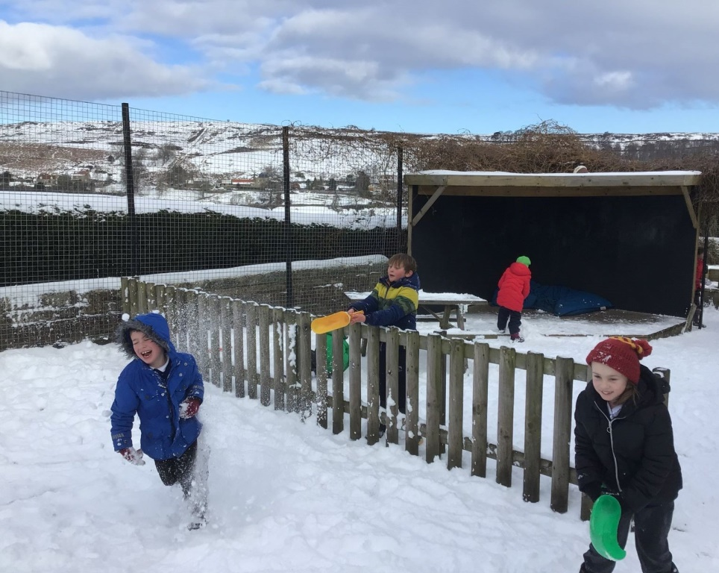

Fun in the Snow

