Message from Mrs Hird
It has been lovely to be back in school this week (and with sunshine rather than snow!) and I’ve been impressed with the learning activities completed by children in class and at home.

As you will have seen from the news, schools will be reopening to all pupils from Monday 8th March and I am very much looking forward to seeing everyone again. The same safety measures will apply as before, both in school and on the playground, so I would be grateful if you could wear a face mask and observe social distancing at drop off and pick up times.

Once children are back in school, we will undertake assessments (after a settling in period) to enable teachers to identify any gaps in their learning and then plan how to address these. We have already started adapting our curriculum to identify the key aspects we would like children to achieve by the end of the academic year, not only in relation to academic subjects but linked to their social, emotional and mental wellbeing. Rest assured that we will do all we can to ensure your child’s transition back into school is as smooth as possible.

Thank you for your continued support.
Mrs Hird

Parental calls
We would like to offer parents an optional telephone call to give you the opportunity to speak to your child’s class teacher prior to their return on Monday 8th March. These calls will be limited to a maximum of 5 minutes and will give you a chance to ask any questions you might have.

Telephone calls for Oak class are available on Monday, Tuesday and Wednesday next week, 2pm to 3pm.
Telephone calls for Acorn class are available next Wednesday, 1.30pm to 3pm and Thursday, 2pm to 3pm.

If you would like to arrange a call, please book through your child’s MCAS log in (as you will have done previously for parents’ evening – listed down the left of the screen).

News from the Classes
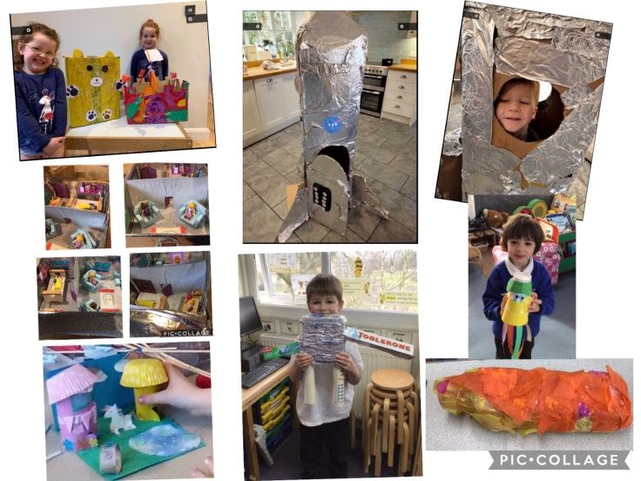
This week in Acorn class we have been thinking a lot about the global problem of plastics polluting our Oceans, we have watched lots of reports and looked at stories that highlight how serious this issue is for Ocean wildlife. Everyone is thinking of ways to try and make a positive difference and we are looking at ways of raising awareness through persuasive writing.
We had a fun week raiding the recycling bags for things to use in our Junk Modelling Art session. Some absolutely fantastic results were seen both in the classroom at home, and some have been inspired to make more than one creation.
Some people have been busy providing a small, pond area to tempt aquatic visitors to their gardens. It's a great time of year to do this as Frogs, Newts and Toads will be looking for places to lay their eggs. If anyone missed this activity, it can be found on Class Dojo.

Spring is just around the corner, and we are going to be having a jolly good Spring clean in preparation for all of the children returning to school. We will also be replacing lots of our tired, plastic containers with more environmentally friendly and enriching ones. We also want to have more open-ended construction resources available to the children with which they can be more creative. So, if anyone has any woven or wicker baskets, of any size or shape that they no longer need or any wooden apple crates or shallow trays we would be very grateful to receive them. Also, any lengths of piping, tubing, wooden planks, empty cable reels, leftover decking boards, blocks of wood, tree trunk sections or any wooden offcuts would be really appreciated. Splinter-free wood is preferred, but we can sand it ourselves if necessary.
Any donations could be brought to school at any time and left in the area outside the Acrorn classroom. Thank you.
Our home learner star of the week is Scarlett for working so hard to complete all of her tasks independently - Well done!
Our school star of the Week is Katie for being so enthusiastic with her learning, especially her independent writing - Keep up this lovely work!

This week the Oaks have begun measuring work in Year 3 and 4. The Year 5 and 6 children have tackled decimals and percentages. Mrs Walley has been impressed by how much their problem solving skills are improving and their determination to succeed when the problems are more difficult.
In English, we have begun looking at the Tuesday picture book and have described the pictures using some relative clauses. We have also begun to learn about newspaper reports and what features they include.
The school star of the week this week is Emma for being much more independent in completing her work.

The home schooling star of the week this week is Joe for working really hard on his own and with Mr Wadley on zoom.
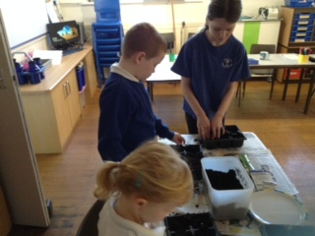

“Early Birds”
Breakfast Club continues every day and this week they have planted some seeds. Easter activities will be taking place and, as the weather has now improved, they will start to spend some time outside.

World Book Day – Next Thursday, 4th March
With World Book Day just around the corner -Thursday 4th March- we would like to make sure we celebrate it- lockdown style! We normally ask children to dress up as their favourite book character but this year, as most children are learning from home, we would like children to decorate a potato as their favourite book character. These will then be judged, and prizes will be given to the winner of the competition (one for the infant class and one for the junior class). A picture of child's entry needs to be emailed in by Wednesday 3rd March. During this week,
we also have lots of exciting activities planned for your children to get involved in. Your child's class teacher will send out details of these in due course.

Singing and Signing Performance for “Let’s Rock Online”
We are very excited to be part of a project organised by Remarkable Arts, in association with the National Centre for Early Music. Children in school have been rehearsing a signing and singing performance which will be recorded on Wednesday or Thursday next week and sent off to be included in “Let’s Rock Online” which will be streamed via You Tube at 6pm on 20th March. They are receiving a letter about this so permission can be given.
It has also been made available to children at home on Dojo. If children at home are to be included in the performance then parents will have to submit their own video recording. Further details and a video showing the song and the actions can be found on the Remarkable Arts website https://www.remarkablearts.net/

Training Day on Friday, 5th March
Just a reminder that next Friday (5th March) is now a training day and school is closed to all pupils. Friday 19th March is no longer a training day and all pupils should therefore attend school on this day.

Music Lessons
Music Lessons with Alix Lille will be able to re-start in school on Monday, 8th March.

Parent Surveys
Thank you to everyone who completed the parent survey last half term. We had 25 responses (54%) and have spent time analysing the results and acting on your suggestions. A summary of the findings is shown below.

My child is coping well with the amount of work. | My child is coping well working in the home environment. | My child is feeling stressed/ anxious at home
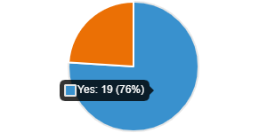 |  | 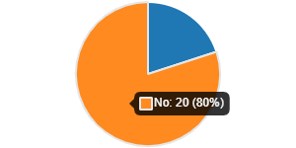
My child knows how to stay safe online | I feel confident to keep my child safe online and know where to access resources. | I am feeling stressed/ anxious about helping my children learn at home.
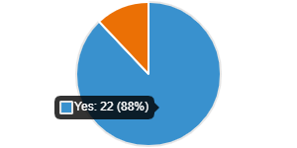 | 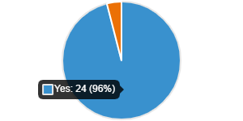 | 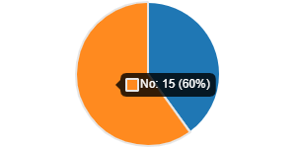
I am feeling confident about helping my child at home | I know where to get support to help my child learn at home. | I know where to access well-being support (e.g online mental health resources)
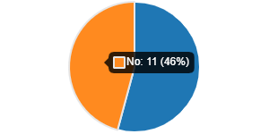 |  | 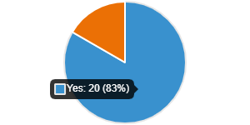
My child has an area at home where they can focus on school work. | My child has access to a computer or tablet at home to do school work | My child is completing all their school work in the set time allocated.
 | 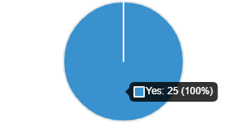 | 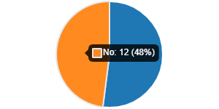
My child receives the right amount of school work to complete. | Do you feel supported by the school during this period? | Are you clear on the school’s expectations for home learning?
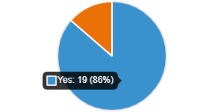

Picking up on some of these aspects, here is some further advice.

Keeping safe online
If you or your child requires support in this area, the following websites may be useful:
https://www.thinkuknow.co.uk/ This includes advice for parents and activities for children age 4 and above.

https://www.nspcc.org.uk/keeping-children-safe/online-safety/ This has a wide range of information and guidance including how to discuss online safety with your child, setting parental controls, understanding different apps and much more.

Sources of support
If you require any support in terms of your child’s education, please contact their class teacher in the first instance and we will be happy to help.

If you would like support for your own wellbeing (or that of your child), the following websites may be useful:
https://www.nhs.uk/oneyou/every-mind-matters/

https://www.mentallyhealthyschools.org.uk/risks-and-protective-factors/coronavirus-supporting-childrens-mental-health/

https://parentping.co.uk/

When asked ‘how can our school provide you with more support for home learning?’ there were a large number of responses which stated that you already feel well supported, which is great to hear. Where there have been other suggestions, we have acted on these where possible, for example making one to one calls available prior to children’s return to school. I’m also aware that a number of parents have been in touch with class teachers during the lockdown and have received support for their needs.

When asked ‘what are we doing well?’ you raised a number of points, which are summarised below. Several parents also felt the provision has improved since the first lockdown, as we have reflected on our practice and acted on your previous feedback.

- Variety of tasks.
- Regular Zoom contact
- Support from staff.
- Routines.
- Use of Tapestry and Class Dojo.
- Keeping children engaged and motivated.
- Encouragement to spend time outside.
- Not feeling under pressure from the school.
- Staff responding to parent feedback.
- Access to school iPads.
- Music lessons

With regards to suggested improvements, again, many parents expressed that they were happy with the provision as it stands. Where possible, we have acted on your suggestions including

- Providing art and science activities
- Live sessions
- Reducing the length of Zoom sessions for younger pupils.
- Changing the format of Zoom sessions.

When asked about your concerns on the impact of lockdown on your child, the vast majority were linked to the lack of social interaction. We will ensure that when the children are back in school, we will balance their academic needs with developing their social, emotional and mental wellbeing and will be revisiting aspects such as turn taking, conversation, resilience and much more through whole class and, where required, group or individual support.
We are also conscious of the potential impact on transition from Year 6 to Year 7 and will be working closely with the secondary schools in order to support this.

We will undertake a detailed review of our lockdown provision later in the term so that we can share good practice and plan any further improvements in case of any future school closures.

