___________________________________________________________________________________________________
Castleton C. P. School
38 High Street
Castleton
WHITBY
North Yorkshire
YO21 2DA

Tel/Fax: 01287 660496
admin@castleton.n-yorks.sch.uk

Headteacher Mrs. J Douglass

Welcome back

It has been lovely to see so many smiling faces back in school this week. I think everyone (parents, pupils and staff!) felt slightly nervous on Tuesday morning but I hope any worries have been put to rest. Although our routines and arrangements in school are slightly different to usual, the children have adapted incredibly well and have been enthusiastic about their learning.
I’d like to officially welcome Mrs Walley to the school, along with all nine(!) of our reception children and our new addition to KS2. It’s lovely to start my headship with so many children on roll and I hope that, as the school’s popularity continues to grow, so do our pupil numbers.
Thank you for your continued efforts with social distancing on the playground. At present, we are unable to have lengthy face to face conversations with parents, as it’s difficult to maintain confidentiality on a busy playground. If you need to speak to a member of staff, please contact the office and we will be in touch as soon as possible.
Whilst attendance is very important, we must of course adhere to the government guidance. If your child or anyone in your household develops any covid-19 symptoms, please do not bring your child(ren) into school and instead call the school office to report the absence and contact the government test and trace service.
Thank you for all your support this week and have a great weekend!
Mrs Hird

Baby News – It’s a Boy!!

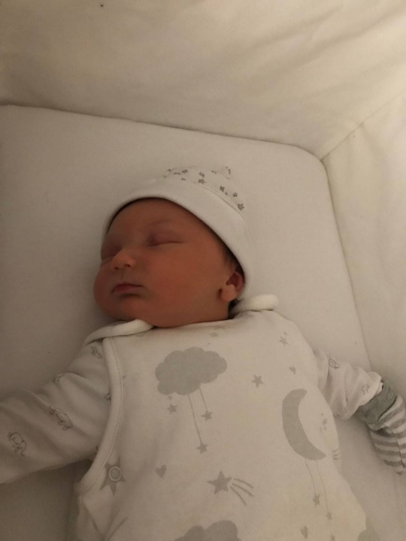
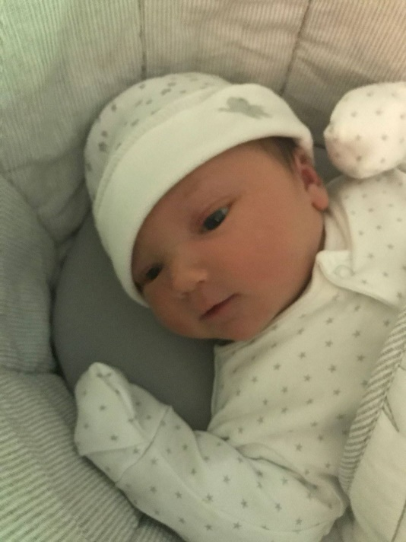

We are sure most of you will probably know that Mrs Porter’s baby arrived on 4th September, Edmund (Ted for short) Joseph Porter, weighing a massive 10lbs 11oz – well done Mrs Porter!!

We are sure you will all agree that he is absolutely gorgeous. Welcome to the Castleton family Ted and enjoy your family time Mrs Porter!

Attendance: This week’s attendance was 97.8% so just above our target of at least 97%.

News from the Classes

KS1: Mrs Barber and Mrs Scholey are both absolutely delighted with the way all of the children in Class1 have settled back into school. It has been such a busy and happy week, hard to believe that this is the first taste of school for our new starters!

The joy of the children seeing friends has been wonderful to witness. The way every child has coped this week has been truly amazing. We cannot praise each and every child enough - well done!

Work has very much focused on gently settling in and making sure that everyone feels happy, confident and settled. Mrs Barber did some lovely work based around The Colour Monster which is a beautiful story focusing on emotions and how we deal with them. We have started to focus on Place Value in maths with year 1 and 2. Our geography topic, which is the make up of the UK, got off to a super start by learning about London and building our own replicas of famous landmarks.

Reception children have settled quickly into class routines and have had fun exploring the different areas of provision. There has been plenty of gluing, sticking, building, role play and many other activities. We look forward to exploring and learning more next week.

Usually we would choose a star of the week but this week that is impossible. Mrs Barber, Mrs Scholey and the whole team feel that the whole class deserves the award. A super week everyone, we are really proud of you all.

Wednesdays will be when Outdoor Science or Forest schools will be delivered, so can children come dressed in appropriate clothing for outside wear (legs and arm covered) and bring coats, waterproofs, wellies or walking boots and their own gloves that are suitable for woodland activities (ie mud) with them as well. They will stay in these outfits all day.

KS2: After a strange summer, it has been brilliant to welcome the juniors back into school to start off the new academic year. They have all adjusted to the array of changes so sensibly and we are all beginning to settle into a long overdue routine once again!

We have warmed up our maths brains with some partitioning of numbers, begun some informative writing about Arctic foxes (plus sketching them too in Art), found some books to enjoy reading, had a PE lesson in throwing and catching, made our own name labels using our ICT skills, as well as the children mind mapping what they already know about light. What an amazing start on top of organisational duties too!

It wouldn’t be right to choose a star of the week this week as they all have truly been stars of the week. Mrs Walley would like to thank them for all their hard work, effort, smiley faces and for making her feel so welcome here at Castleton.
PTFA News
As you may be aware, Helen Hellon has now stood down as Chair of the PTFA. Although it was before Mrs Hird’s time as Head, she has heard lots of positive comments about the impact of the PTFA at Castleton and would like to thank Helen, on behalf of the school and our pupils, for all her efforts.
As a result, we would now like to appoint a new Chair, as well as inviting any other interested parents to join the PTFA. Covid restrictions will mean this has to run slightly differently in comparison to previous years but we are sure that, through the wonders of technology, we can still raise funds and make improvements to every child’s school experience.
The level and type of commitment will depend on your availability. You don’t need any specialist skills, just a willingness to support the school. If you would be interested in joining the PTFA, please could you let Mrs Blacklock in the office know by phoning the school or sending an email to: admin.castleton@yeat.co.uk

Roald Dahl Day
This weekend it is Roald Dahl day and we will be celebrating in school next week with class-based activities. Children will need to wear school uniform so there’s no mad dash to find a fancy dress outfit, but if you happen to have any Roald Dahl books at home, these would make a great choice for story time over the weekend.

“Sing up Day” 2020
You may remember that back in March the children were recorded (with your permission) singing this year’s “Sing up Day” song – “There’s a Power in the Music.” Luckily we managed to get it done before the school closed! The digichoir video has finally been released so below is the link to enjoy watching it together at home:
www.singup.org/sing-up-day
Many thanks to Miss Wilson for organising this.

Music Lessons with Alix Lillie
Music lessons with Alix Lillie will be starting on Monday morning at a cost of £7.50 per lesson. Alix is able to offer lessons in piano/keyboard, guitar, ukulele, harp, drums, flute, clarinet, saxophone, accordion and penny whistle. If your child/children would like to start lessons with Alix please ask Mrs Blacklock for a letter.

Breakfast Club
We confirm that Breakfast Club is continuing every morning and costs £3.50 (including breakfast) from 8am or £1.75 from 8.30am. Please telephone or email Mrs Blacklock if you would like to book your child/children in.

“My Child at School” (MCAS) Parent Portal
Mrs Blacklock has started “rolling out” MCAS to parents. She is emailing information out gradually and you should all receive the details needed for creating an account by the end of next week. It is through here that Dinner Money and all other payments to school now need to be made. You will also be able to view Attendance, update contact details and it can also be used as a means of communication between us.

Governor Recruitment
Would you or someone you know be interested in joining our governing body? We are ideally seeking candidates from the local communities of Castleton, Glaisdale or Lealholm who are NOT parents of current pupils, as these areas are currently underrepresented.

For more information about the schools and how to apply, please visit our website at: https://www.castletonprimaryschool.co.uk/about-our-school/our-governors/

Next Week
Monday Music Lessons with Alix Lillie
Wednesday KS1 Outdoor Science or Forest Schools. Children can come to school dressed in appropriate clothing
Thursday PE for all children. Please make sure children have their PE kit in school

