__________________________________________________________________________________________

Message from Mrs Hird
Welcome back! It has been wonderful to see everyone in school this week. Thank you for returning any borrowed iPads and chargers and for observing social distancing when dropping off/picking up children.

As some of you may be returning to work over the coming weeks, I just wanted to remind you about our fantastic breakfast club, which runs from 8am every morning. Children are provided with breakfast and a range of activities to keep them entertained before school starts. Places need to be booked in advance (the day before is fine) and your child can attend regularly or as a ‘one off’ whenever it suits your needs.

Have a lovely weekend.
Mrs Hird
Attendance: This week’s attendance was a fantastic 99.56% so well above our target of at least 97%.

News from the Classes
This week it was just so wonderful to welcome all of the Acorns back into class. We have really missed the home learners and to see the classroom buzzing again was really wonderful. Everyone has slotted straight back into school life, even though we have made some exciting changes to the classroom layout and the resources outside.

In Literacy, we decided that it would be nice to make our own spring books as we are learning about non-chronological reports. We have been thinking about how busy the blackbird is right now with nest building, and shortly, with the laying of eggs.
Lots of practical activities in maths are occurring as we learn about 3D shapes and measuring length and height.
We have continued our learning in school about Florence Nightingale, thinking about the improvements she made to the hospital in Scutari. We have fun playing versions of Stuck in the Mud pretending to be germs spreading and disabling people until released by good care!
Easter is obviously a focus of the term. Using props, the children enjoyed retelling and sequencing the Easter story. Next week we will look forward to talking about the different ways people celebrate the festival.
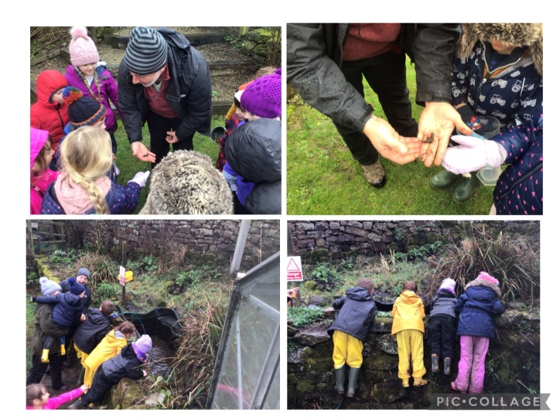

We had a real treat on Wednesday afternoon as Mark, our wildlife and gardening friend, came to spend the afternoon with us. Such fun was had emptying and refilling the garden pond, which had become less than hospitable for wildlife, and stocking up our new Bug Hotel.

It was lovely welcoming Lewis and Jess into school for our weekly P.E. sessions. The children thoroughly enjoyed themselves and impressed both teachers.

The Acorn Star of the Week is Alfie H for fantastic reading and having amazing enthusiasm. Displaying a keenness to complete books and reading at home.

We are so proud of how the Oaks have re-joined school or swapped into our normal routines. They all came with a positive attitude and enjoyed catching up with friends.

In maths, we were able to continue with percentages and decimals in years 5 and 6 seamlessly, as they had all worked so well at home. In years 3 and 4, we have finished the unit of measuring and have just moved onto fractions.
For our writing this week, we have been changing our newspaper reports to be our own, remembering to include the features that are important to this genre.

Our afternoon work has been a mix of PE, dance, creating model Earths (with plasticine) and bunting making!

We have two Stars of the Week this week.
The first is Jasmine for working hard in all lessons this week.
The second is Ryan for some great answers in his maths work.

Whitby and DistrictYoung Musicians Competition
Many congratulations to Rosie for coming joint 2nd in the above competition, a fantastic achievement! You may have had the pleasure of watching her video online!

Reminder - Whitby & District Rotary Club – Story Writing Challenge
If your children are interested in entering the above competition (details in Newsletter 29th January) the deadline is on Monday(15th March).

Red Nose Day – Next Friday (19th March)
We will be having the usual non-uniform day next Friday and children can come to school dressed as superheros or wearing red etc. Children are allowed to wear these clothes for “Dance” so please make sure they have trainers and the clothes are suitable. Any “accessories” can be taken off and left in school.

A JustGiving fundraising page has been set up for donations: www.justgiving.com/fundraising/castleton-school
Down Syndrome Awareness Week
Next week is Down Syndrome Awareness week and incorporates World Down Syndrome Day on Sunday 21st March. We plan to support this in school on Monday, 22nd March by encouraging the wearing of odd socks and donations of £1. We will be reading stories and making something out of odd socks so could you please send any spare socks in! Thank you.

Yorkshire Endeavour Academy Trust AGM – 23rd March
Yorkshire Endeavour Academy Trust will be holding the Annual General Meeting (AGM) on 23rd March 2021 at 5.30pm. Details available on the Trust Website at
https://www.yeat.co.uk/about-our-trust/governance/notice-of-annual-general-meeting-agm/
or contact company Secretary, Sharon Markham via email companysecretary@yeat.co.uk for full details and how to join the meeting.

Next Week
Monday Music Lessons with Alix Lillie. Please remember instruments.
Wednesday All pupils Outdoor learning. Children can come to school dressed in appropriate clothing - lots of warm layers, with waterproofs, wellies and gloves.
Thursday PE for all pupils. Children to come in uniform.
Please make sure they have their PE kit in school.
Friday Red Nose Day (non-uniform)
Dance for all pupils

