__________________________________________________________________________________________

Message from Mrs Hird
Due to attending a training course this week, I was only able to be in school on Wednesday but what a day it was! I watched our fabulous Reception children developing their maths understanding with a fun (and rather wet) activity in the water tray, where they were taking turns and talking about their learning. Key Stage 2 arrived back from their outdoor learning session in the school gardens with big smiles and rather muddy clothes after making clay pots linked to their Stone Age history topic.

Another high point for me this week was reading the reasons why children had chosen their ‘trusted adult’ in school. My favourites were the fact that Mrs Blacklock was chosen because ‘she keeps everyone organised’ and Mr Wadley was chosen because, ‘You gotta trust him – he’s a mathematician!’ I definitely agree!

As we move into the final week of the half term (which has flown by!), we’re looking forward to sharing our harvest celebrations with you and holding our virtual parents’ evening meetings.

As always, if you have any questions or queries, please feel free to get in touch.
Have a great weekend. Mrs Hird

Attendance: This week’s attendance was 98.22% so, again, above our target of at least 97%.

News from the Classes
In KS1 everyone has been working very hard this week, thank you so much.
In maths, Year 1 have been introduced to representing numbers using the part-whole method. Year 2 have been using part-whole and bar model methods of representing number facts to 20. Although tricky concepts to grasp, they really help with understanding how numbers are made up.
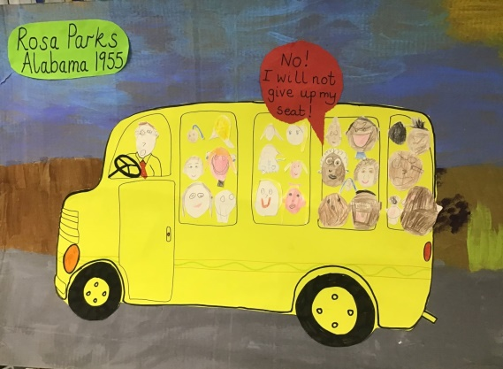
In English, we have moved onto the second of our traditional tales, Little Red Riding Hood. We are enjoying looking at the sequence of events that make up the story and meeting the characters from it.

As October is Black History month, we have looked at the story of Rosa Parks and how she influenced a change in history and how black people were treated during segregation in America in 1955.
We re-enacted her iconic bus journey (with some very determined and convincing thespians) and discussed how it made us feel to hear of how black people were treated at this time. Finally, we made our own bus, filled with passengers seated in the way that they were made to in those days of segregation.
Everyone was really quite shocked to learn that it was a way of life for
black citizens in America at that time.
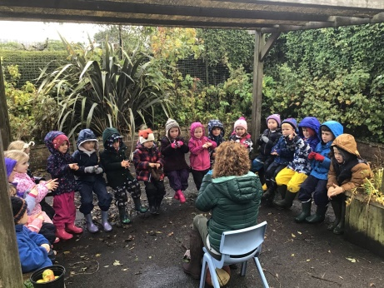
Also this week, we enjoyed some outdoor science time where we looked for evidence of seasonal changes. The garden is full of fallen leaves, in all colours, juicy ripe apples that have fallen from the trees and shiny red hips on the rose bushes.
Our outside learning session was finished off with something really special. Sophie shared a wonderful story about a fairy who was hard of hearing and kept getting muddled up with her wish requests! We then learned how to sign our names and then sang and signed "If you're happy and you know it."

This week's Star of the Week is Ivan, for being hardworking, polite, friendly, helpful and a thoroughly “good egg”!!

KS2 have worked hard on planning and changing our adventure story to make it their own this week. The children have been building their writing stamina whilst also taking care with their handwriting and presentation. It was lovely to hear the variety of story starters when the children read them aloud. In maths, Year 3 and 4 have looked at negative numbers and Year 5 and 6 have been multiplying 2 and 3 digits by 2 digits in a variety of different ways.
Our highlight this week was designing and making our sandwiches today. The children enjoyed tasting the different breads and then making the sandwich on their own. Can they make you a sandwich this weekend I wonder?

Please can children bring a waterproof coat into school EVERY day? This will ensure we can get them outside as much as possible for fresh air and for P.E lessons. Many thanks for your support with this.
Star of the week is Maddy for always listening well, working quietly and doing her best.
Harvest
Our virtual harvest celebrations will be shared with parents next week.
With regards to donations, we are sadly unable to accept these in school but instead would like to invite all our families to make a donation either directly to a food bank or via a food charity collection at a supermarket. One of our governors had the fantastic idea of taking a photograph of you and/or your child making a donation and then either emailing it to school or posting it on our Facebook page, with the hashtag #givingforharvest so we can celebrate the kindness of our children.
Thank you in advance for your support.

Remote learning
You should now have received a letter detailing our plans for remote learning in the case of any school closure. Please ensure that you return the letter stating whether or not you need to borrow a school iPad by Monday 19th October. Hopefully, we won’t need to return to remote learning but it’s always best to be prepared!

Parents Evenings – Week commencing Monday, 19th October
The Zoom details are being emailed out to relevant parents today in KS2 and will be emailed on Monday morning to EYFS/KS1. When you use this to enter the meeting, you will be taken to a waiting room and teachers will allow you entry to the meeting from here. In order for this to work effectively, we ask that you change your screen name to your child’s name so that we can easily identify you (sometimes the make of the phone is used as the default screen name).
EYFS and KS1 appointments are from 2.10pm to 5pm on Monday.

KS2 appointments are on Monday 19th, Tuesday 20th or Wednesday 21st 3.40pm to 5pm.

Yorkshire Endeavour Academy Trust
Notice is hereby given that the Annual General Meeting of the Yorkshire Endeavour Academy Trust
will be held virtually on Thursday, 22nd October at 4pm

For further details please use this link:
https://www.yeat.co.uk/latest/notice-of-annual-general-meeting-agm1/

“Wear it Pink” Fundraising Day for Breast Cancer, Friday, 23rd October
Next Friday is the annual “Wear it Pink” non-uniform day when children can come to school wearing pink to raise money for this worthwhile cause. There will be a collection box outside for donations.

Medical Rolling Consent Form 2020/21
Further forms have been given out today to pupils who have not returned one - please complete and return next week as it is very important that we have up to date medical and contact details for when pupils are off the premises during this school year. Please also remember to notify us of any changes to these details throughout the year.

Christmas Shoebox Appeal
We won’t be doing Christmas Shoeboxes in school this year but if anyone would like to do this at home, please ask Mrs Blacklock for a leaflet or speak to Jen Littlewood who will be passing the completed boxes on.

Next Week
Monday Music Lessons with Alix Lillie. Please remember instruments
EYFS/KS1 Parents evening – 2.10 to 5pm
KS2 Parents Evening – 3.40 to 5pm

Tuesday KS2 Parents Evening – 3.40 to 5pm

Wednesday All pupils Outdoor learning. Children can come to school dressed in appropriate clothing - lots of warm layers, with waterproofs, wellies and gloves.
KS2 Parents Evening – 3.40 to 5pm

Thursday PE for all pupils. Please make sure children have their PE kit in school. EYFS/KS1 to arrive in PE kit; KS2 to arrive in uniform (we will change into kit before our lesson)
YEAT Annual General Meeting, virtually at 4pm

Friday “Wear it Pink” non-uniform day for Breast Cancer
Break up for half term holiday

