___________________________________________________________________________________________________
Castleton C. P. School
38 High Street
Castleton
WHITBY
North Yorkshire
YO21 2DA

Tel/Fax: 01287 660496
admin@castleton.n-yorks.sch.uk

Headteacher Mrs. J Douglass

Message from Mrs Hird
It has been another lovely week in school and everywhere feels very positive and purposeful.

The Oaths
Some of you may remember that we launched the ‘Esk Valley oaths’ last year (and if you need a reminder, they are displayed on the school railings). We are keen to link our learning to the oaths, wherever possible, and will be exploring covid-secure ways of addressing them throughout the year. This week, our learning has helped us to build on at least two of the oaths:
- Develop a love of reading through celebrating Roald Dahl day.
- Have regular outdoor learning experiences through our forest school activities.

Covid update
I thought it would be useful to share with you our current procedures for dealing with any illness.

If you contact school to inform staff that your child is ill, we will ask the following questions:

Does the child have any of the following symptoms:
- A new, continuous cough;
- A high temperature;
- A change to, or loss of, their sense of smell or taste?

If the answer is YES to ANY of these symptoms, the whole household is expected isolate and the child (and anyone else in the household with covid symptoms) must arrange to be tested, in line with government guidelines.

If the answer is NO, the child is able to come into school as long as they feel well enough to do so.

If you are leaving a message on the answerphone to report any absence, please could you specifically confirm whether or not your child has any of the above symptoms.

If any member of your household displays any of the above symptoms, the same process applies as above (isolate and any household members with symptoms are tested).

If a child becomes ill with covid symptoms whilst they are at school, we will:

Immediately isolate the child (and any siblings) in school and supervise them with social distancing in place.

Make contact with the child’s parent/guardian, asking for the child to be collected as a matter of urgency.

When the child is collected, the parent/guardian will be advised by a member of staff of the need to isolate all members of the household with immediate effect and to contact the test and trace service to book a test for the child.

If we are informed that a member of the school has tested positive for covid-19, we will seek advice immediately from the local public health team and contact parents with the outcome.

It is possible that this will result in a whole school closure until the isolation period is completed.

Thank you for your patience and understanding. Our staff are not trained health professionals and cannot make any medical decisions; we can only follow the guidance we have been given and continue to follow our safety and hygiene procedures in school.

Plans for possible school closure
Whilst we hope that our school will be able to remain open, we need to be prepared for closure in the event of a confirmed case of covid-19.
We have therefore agreed as a staff how we will continue to teach our pupils in the case of either teacher absence or school closure. Full details will be sent out next week but I can now provide you with an overview.
We are currently setting up individual pupil iPads, which we will send home with pupils in the case of school closure. Learning tasks will be set via Class Dojo and children will have the opportunity to practise using it in school. We will also send out instructions for parents and a list of other apps and activities that children can access.
In order to set learning tasks, we will need to create individual pupil logins on Class Dojo. If you do not consent to setting up a pupil login, please let Mrs Hird know via headteacher.cg@yeat.co.uk

Ainthorpe Educational Trust
We are thrilled to have been awarded £300 by the Ainthorpe Educational Trust and would like to offer our thanks to the committee. We will be spending the money on books which link to the Key Stage 1 maths curriculum.

Parents’ Evening
Due to the pandemic, we will be holding this term’s parents’ evening via video or telephone call during wc Monday 19th October. The appointments will be booked via the ‘My Child at School’ app. Further details about appointments and how to book them will be sent out nearer the time.

Thank you for your continued support. Have a lovely weekend. Mrs Hird

Attendance: This week’s attendance was 95.24% so, unfortunately, below our target of at least 97%.

News from the Classes
KS1 have had a very busy and productive week 😊
We have been busy recapping some of the maths from before lockdown, namely numbers within 10 and 50. Counting, ordering, forwards and backwards and partitioning to recognise tens and units. We are also really focusing on reasoning and problem solving, which means answering wordy problems by choosing the correct calculation for the job. It’s quite a challenge, why not have a practise at home?
In English, we have been enjoying the story of the Three Little Pigs, as we look at Traditional Stories this term. We are trying to learn the story off by heart so that we can retell it in many different ways. So far, we have listened to the story and built the houses as we go, played with story puppets, acted it out with role-play masks on, held up wooden spoon story prompts whilst one of us narrated it, retold the story through sequencing pictures and made a start with a story map! We will continue with the story map next week and use it to support our writing.

We have also been busy doing self-portraits for a class display. This has involved us looking in mirrors and paying particular attention to our face shapes and features. Everyone has done so well and the portraits are really accurate. Hopefully, we can share a virtual gallery of them with you soon and you can see for yourself.

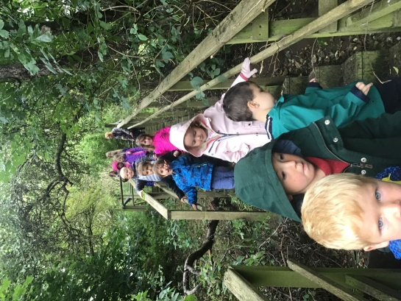
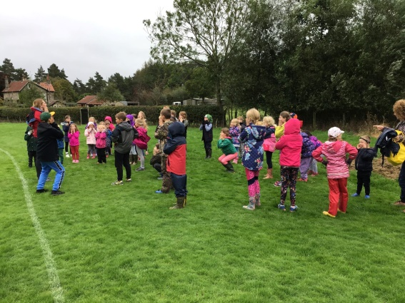
We had a lovely session on Wednesday afternoon where, along with KS2, we explored the school garden, the access path to the Cricket field, and the Sports field area. We were mainly focusing on our Science topic which is Seasonal changes, but we were also there to explore our outside areas and have some fun! It was lovely to see all the children spread out and enjoy themselves.

Next Wednesday, we will visit our Forest School site in the morning, so please come dressed ready for some messy, outside adventures.

Mrs Scholey and I continue to be blown away by how amazing the children have been at returning to school and settling down to all of our learning routines. We have had a large intake of Reception children who have had to learn all about school life. One little girl only realised that she was going to be joining us during the Summer holidays and as a result, wasn't able to make it to any of our taster sessions to visit the classroom and meet her classmates or teachers. Despite this, she has been absolutely amazing since day one at coming into class and joining in with her learning. She is friendly and kind to everyone and she is an absolute whizz at reading and writing phonics. Well done Martha, you are our Star of the Week 🌟 Mrs Barber

Tapestry – Reception
All of the Reception children now have a Tapestry Account. Miss Wilson will add observations of the children on here every other week.
Once we receive your user permission slip, a unique link will be sent to your provided email address to activate your account. Please check your “Junk” folder in case it appears there!
Please feel free to add comments to any observations and to also add your own from home so we can build up a bank of evidence to show the children’s learning.
Thank you for your support.

In KS2 the week began by celebrating Roald Dahl day. The children learnt a Roald Dahl Poem in groups. They worked together to help each other remember different sections, rehearsed and performed it on our outdoor stage. We then used a poem as a model and the children composed their own versions.
We continued with our place value work in maths, using number lines, rounding numbers, using place value charts and problem solving with these concepts too.
We have had Lewis deliver the first session of golf for us plus we explored down the cricket field and playing field too, where we played some teamwork games.

Star of the week is awarded to Scarlet Baker for having a super attitude to her work and using her good manners. Mrs Walley
Flu Immunisations in School for all children on Monday, 5th October at 1pm
You should all have received an email on Monday attaching a letter from the Childhood Immunisations Team which included details for consenting online at: https:/www.hdft.nhs.uk/fluconsent/
School Code of: 144680 should be entered and then click “Find School”

Consent must be given online, so that your child can receive their immunisation, by 28th September (not 5th October as stated in the letter). If you have any queries please get in touch with us.

Year 6 Secondary Transfer 2021
Information was sent by email to year 6 parents on Monday about applying for a Secondary School please.
This must be done before 31st October.

My Child At School (MCAS) Online Parent Portal
Information has now been emailed out to all, with instructions on how to set up account details. Payments for Dinners, Music Lessons and Breaktime Drinks should now all be made online through the Portal. If you have more than one child it is possible to switch between them by clicking on the name (to the right of where their photograph could be) and it will open a list with drop down arrow to select a sibling.

Music Lessons – Change of Day next week to Tuesday
For pupils who have music lessons, Alix Lillie is coming on Tuesday morning next week, instead of Monday. This is for one week only.

Change to Dinner Menu and Breaktime Fruit/Drinks
Please note that Gaby is changing the “Week 3” Friday dinner (next week and for the rest of the Term) from Salmon and Sweet Potato Fishcake to either Fish Fingers or Battered Fish.

Fruit is available free every breaktime (this is really just for KS1 but we usually have enough to give KS2 some as well!) All pupils can have a drink (cost 25p) and can choose from milk or an orange/apple juice carton.

Drinks should now be paid for online through “MCAS” – under “Products”, listed down the left. You will be able to pay for as many as you wish at a time and Gaby keeps a record of when children have a drink so we can let you know when more will need to be paid for. Thank you.

Governor Recruitment
Would you or someone you know be interested in joining our governing body? We are ideally seeking candidates from the local communities of Castleton, Glaisdale or Lealholm who are NOT parents of current pupils, as these areas are currently underrepresented.

For more information about the schools and how to apply, please visit our website at: https://www.castletonprimaryschool.co.uk/about-our-school/our-governors/

Next Week
Tuesday Music Lessons with Alix Lillie. Please remember instruments
Wednesday All pupils Outdoor Science/Forest Schools. Children can come to school dressed in appropriate clothing
Thursday PE for all pupils. Please make sure children have their PE kit in school

