__________________________________________________________________________________________

**Message from Mrs Hird**

It's been another eventful and exciting week with lots of outdoor activity and enthusiastic talk about our learning. We were delighted to welcome Mrs Zanelli, the CEO of our Trust, into school on Wednesday and she enjoyed her time so much that she didn't want to leave! We have lots of new projects and improvements to the school environment planned for the summer term and can't wait to share details of these in future newsletters and on our Facebook page.

Have a lovely break over Easter and I look forward to seeing everyone back in school on April 12th.

*Mrs Hird*

**Attendance:** This week’s attendance was **91.17%** so below our target of at least **97%.**

**IMPORTANT - Positive Covid Tests**

If your child tests positive for covid during the school holidays, please can you inform Mrs Hird by email at: [headteacher.cg@yeat.co.uk](mailto:headteacher.cg@yeat.co.uk) in line with the guidance below. You will also need to follow the government guidance with regards to household isolation.

**All children who have been in school on the same day(s) will also need to isolate for 10 days as a close contact and you will be advised of this by the school.**

Close contacts are taken from 2 days before the person develops symptoms or (if there are no symptoms) tests positive. Therefore, if your child develops symptoms within two days of attending school, you will need to inform Mrs Hird, even if their positive test result doesn't come through until later in the week.

|  |  |  |  |  |  |
| --- | --- | --- | --- | --- | --- |
| Day | Thursday | Friday | Saturday | Sunday | Action required |
| **Situation 1** | Child attends school | Child absent |  |  | Inform Mrs Hird as soon as the positive test is confirmed. |
| Child develops Covid symptoms and subsequently tests positive | | |  |
| Day | Thursday | Friday | Saturday | Sunday | Action required |
| **Situation 2** | Child attends school | Child attends school |  |  | Inform Mrs Hird as soon as the positive test is confirmed. |
| Child develops Covid symptoms and subsequently tests positive | | | |
| Day | Thursday | Friday | Saturday | Sunday | Action required |
| **Situation 3** | Child absent | Child attends school |  |  | Inform Mrs Hird as soon as the positive test is confirmed. |
|  | Child develops Covid symptoms and subsequently tests positive | | |

If your child develops symptoms on **Monday or later**, you do not need to inform Mrs Hird but will need to follow government guidance.

**News from the Classes**

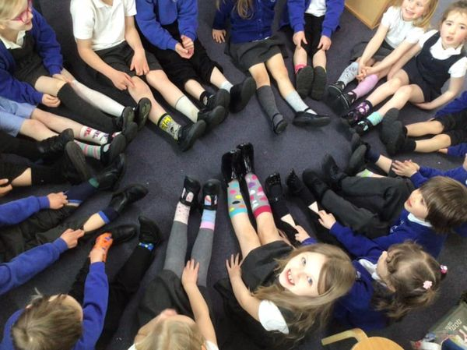The **Acorns** started the week by wearing odd socks on Monday, to support World Down Syndrome Day which was last Sunday. We had an enjoyable afternoon making “Socktopuses” (Octopuses out of odd socks), coloured in mindfulness socks and played sock pairing activity games.

In Maths this week, Year 1 looked at weight and capacity and Year 2 3D shapes (in particular, faces, edges and vertices).

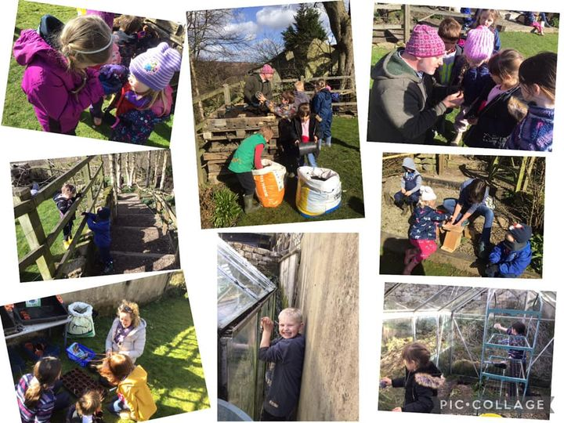

We have enjoyed completing our Spring books and writing long chronological reports about Spring. We have looked, in particular, at how busy the blackbird is at the moment building her nest and preparing to lay her eggs.

We had another wonderful Wednesday afternoon in the school garden with the help of Mark, our gardening friend. Everyone was very busy with seed planting, bird box building, creating the roof garden of the bug palace and cleaning the greenhouse glass. Many hands make light work!

The week ended today with an “eggciting” Easter themed day making cards, decorating eggs and having an egg rolling race.

**Acorn Star of the Week** is **Layla** for extending her learning in measuring and showing great enthusiasm when comparing lengths of dinosaurs.

There has been lots going on with the **Oaks** this week.  In reading and writing, we have looked at the ‘Highwayman’ Poem.  We have discussed new vocabulary and looked in depth at the story that was being told through the poem.  The children have also written some questions to ask suspects and witness statements using their imaginations.

In Geography, we have loved researching about two volcanoes that are currently erupting- Mount Etna and Iceland’s Fagradalsfjall.  Seeing the photos, videos and drone footage really brought this learning alive!  Mr Wadley and Gaby also brought in some volcanic rock from Etna and Vesuvius for us to study.

The children worked well in an outdoor RE session thinking about God.  They thought about if God were different things. E.g. If God was a weather, what would he/she be?  They came up with some great responses with reasons for their thinking too.

The children enjoyed a special fly over from the Police helicopter at the end of the day on Wednesday.  We made sure they didn’t miss us with some big waves!

To end the week we solved a mathematical Easter mystery, had a team egg hunt plus some dancing and games with Jess.



The **Oaks have 2 Stars of the Week: Jordan** for working hard in all of her work, especially her writing and also for looking out for the younger children in the school.

**Rosie** for thinking of others and solving friendship problems in a sensible way.

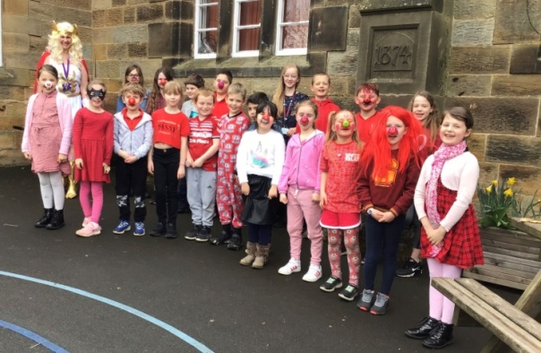

**Charity Fundraising Thanks**

Thank you very much for the kind donations to **Comic Relief** when £90 was raised from our non-uniform day.

We had great fun wearing odd socks to school on Monday in support of **World Down Syndrome Day** which was last Sunday and donations amounted to £50.

**Dinner Menu and Holiday Dates**

Enclosed is next term’s Dinner Menu but please note that on the first Tuesday back it is going to be Chicken Korma and not Pasta with Tuna!

Also, please find attached the school holiday dates from September.

**PE and Uniform**

Please note that after Easter, Acorns will have a PE session on Tuesday, all will still have PE with Lewis on Thursday and Oaks will continue having their other session on Friday. On these days, please make sure the correct PE kits are in school and pupils should come in their uniform.

It would be really helpful if Reception children could practise dressing and undressing independently to assist when changing for PE in school! Also, please make sure that all uniform is named.

**After School Clubs– Commencing Monday, 12th April**

Slips have now been sent home with pupils for the after schools clubs which will start on the first week back and all have a finish time of 4.15pm. Please make sure these are completed and returned. Lewis will be running a Football Club next half term on Thursday and slips for this have been handed out to children today.

**Week Commencing Monday, 12th April**

**Monday** Music Lessons with Alix Lillie. Please remember instruments.

Choir after school (Oaks).

**Tuesday PE for** **Acorns (please note change of day!)**

**“**Signing” after school.

**Wednesday** **All pupils** **Outdoor learning**. Children can come to school dressed in appropriate clothing.

**Thursday** **PE for** **all pupils**.

Football after school.

**Friday** **PE for Oaks.**

**j0304933**