__________________________________________________________________________________________

Message from Mrs Hird
It has been another enjoyable week at Castleton, with lots of exciting learning activities taking place. We have been ordering new resources to support learning and thinking about how we can safely celebrate traditional events such as harvest.

Class names
We have decided to choose names for our two classes, rather than referring to them as EYFS/KS1 and KS2. I would like pupils, parents, staff and governors to be involved in the process and therefore invite you to send any suggestions for class names to me via headteacher.cg@yeat.co.uk by Friday 2nd October. We will then compile all the suggestions and vote for our favourite.

Plans for possible school closure
Our teachers all had training this week on how to use Class Dojo to set learning tasks. Whilst we are hoping that we will be able to remain open, in the unfortunate event that we do have to close the school as a result of covid-19, we will be delivering our remote learning through Tapestry (Reception) and Class Dojo (Years 1 – 6). Individual iPads are almost ready for use and we will spend time in school showing your children how to access remote learning activities so they are fully prepared. Further details will be sent out once the children have had an opportunity to practise in school.

Key worker provision
If you have not already done so, please complete and return the ‘key worker provision’ letter sent out recently, if you class as a key worker and will require childcare in the event of school closure. The deadline for returning forms is today (Friday 25th September).

Thank you for your continued support. Have a lovely weekend. Mrs Hird

Attendance: This week’s attendance was 96.76% so just below our target of at least 97%.

News from the Classes
Although the weather has not been fantastic this week everyone in KS1 has been an absolute ray of sunshine and really enjoyed the tasks that they have participated in.

Work on the Three Little Pigs in English was very practical this week with house building taking place. Luckily, Mrs Barber had plenty of straw and sticks to hand! It proved to be a great stimulus for instructional writing for the older children and for story telling with the younger ones. It was so lovely to see everyone really engrossed in the tasks, discussing and explaining what they were doing and why. Year 1 have continued thinking about numbers to 10. There have been lots of practical tasks thinking about one more and comparisons of two sets to see which is the greater, less or equal to. Year 2 continued learning about place value whilst trying to work a little more independently. Again, there have been lots of practical tasks, whilst Reception have had enormous fun matching items. Each morning they continue to participate in a carousel of activities that encourage fine motor skills and the principles of early maths.

At the beginning of the week, Mrs Lillie came into class to demonstrate some of her musical instruments and talk to the children about them. We have some very knowledgeable children with regards to the instruments, and a few are keen to have lessons with her. We shall look forward to hearing how they get on.

We had an enjoyable time in our Forest School session, despite the wet weather. A spare set of dry clothes is a good idea on particularly wet days, though we always have spare clothes in school and were able to provide these for children whose waterproofs proved to be slightly less waterproof than hoped. Please could we ask everyone to remember to bring suitable outdoor clothing, including their own pair of gloves, and a change of clothes.

Just a quick reminder about homework. Please could you read with your child every night if possible. Little and often really is the best. Spellings for year 1 and year 2 were given out last week and will be tested on the 2nd of October.

Our Star of the Week this week is Finley for being brilliant at our Forest School session.

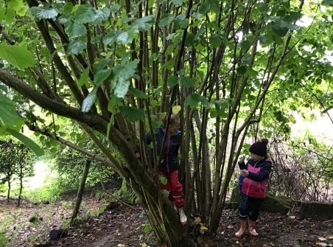
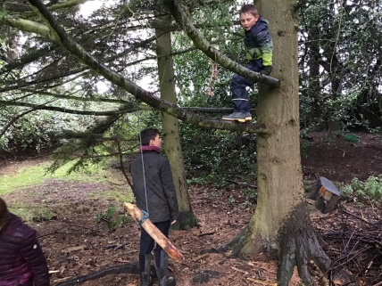
KS2 have been working hard on creating their own blueprints of inventions that would help tackle the coronavirus. They have also looked at the features of an explanation text so that they are ready to write their own about their invention. There are some weird and wonderful creations that we cannot wait to find out more about!
In maths, the Year 3s and 4s have been counting in 50s and 25s, as well as comparing numbers while the Year 5s and 6s have continued to add larger numbers using the column method, moving onto subtraction in the same way.
Our highlight this week had to be our forest school session in the rainy weather. The children showed me around the site and we certainly were thankful for the shelter in various forms. Please ensure children have plenty of layers under their waterproofs, that waterproofs are waterproof enough, that they bring their gloves with them and that they have some dry clothes for when we return to school and need to change into dry clothes.
Homework - please remember to encourage your child to read every day. They learn a vast amount of vocabulary from the books they read. If you can help them find out what new words mean, this will help their understanding. Also, children that read well are more likely to be able to write well too!
I have set ‘sessions’ on Times Table Rockstars so that children complete 20 mins throughout the week plus a sound check. I will continue to check on how they are doing and challenge them with new tables when needed.
Hopefully, the children have chosen their task from the homework grid and are beginning to plan what they will do. I will look at the homework books in the week beginning 5th October to check on their progress.
Spellings are also coming home today with the first 10 labelled to practise before next Friday, when the children will be tested on them. I have shown the children some alternative ways to learn them; please ask if they can remember any!
Star of the week this week is Kobie as he has worked hard with all his work and shown good listening skills to help him be able to work independently. Mrs Walley

Medical Rolling Consent Form 2020/21
Please find enclosed the annual Form which must be completed for every child so that we have up to date medical and contact details for when pupils are off the premises during this school year. It is important that you notify us of any changes to these details throughout the year. Please complete and return the Forms early next week.

Year 6 Parents – Message from Eskdale School
The COVID-19 pandemic has meant that we are unable to offer a Year 6 open evening at this time, however we realise the importance for year 6 students to visit the school to help make the important decision regarding your secondary school preference. Mr Fyfe is happy to take families on tours of the school from 4pm until 7.30pm on most school days apart from Friday and part of Wednesday. He will take one family at a time and will ask that we follow basic PPE guidelines such as face mask and keeping a reasonable distance from one another. These tours will last 30 mins and can be booked via Miss Becky Sutcliffe, PA to the Headteacher.
We will also be posting YouTube videos of the school tour over the next few weeks.

If you would like to speak to Mr Fyfe, please feel free to contact the school.

Please also remember that application for a Secondary School place must be done by 31st October.

Cakes in school
Due to the current covid restrictions, please can we ask that parents do not send any cakes or other treats into school to celebrate your child’s birthday. Thank you.

Flu Immunisations in School for all children on Monday, 5th October at 1pm
You have all received an email attaching a letter from the Childhood Immunisations Team which included details for consenting online at: https:/www.hdft.nhs.uk/fluconsent/
School Code of: 144680 should be entered and then click “Find School”
Consent must be given online, so that your child can receive their immunisation, by 28th September (not 5th October as stated in the letter). If you have any queries please get in touch with us.

PTFA
As mentioned previously, we need to appoint a new Chair for the PTFA, as well as inviting any other interested parents to join. Covid restrictions will mean this has to run slightly differently in comparison to previous years but we are sure that, through the wonders of technology, we can still raise funds and make improvements to every child’s school experience.
The level and type of commitment will depend on your availability. You don’t need any specialist skills, just a willingness to support the school. If you would be interested in joining the PTFA, please could you let us know by phoning the school or sending an email to: admin.castleton@yeat.co.uk

Governor Recruitment
Would you or someone you know be interested in joining our governing body? We are ideally seeking candidates from the local communities of Castleton, Glaisdale or Lealholm who are NOT parents of current pupils, as these areas are currently underrepresented.
For more information about the schools and how to apply, please visit our website at: https://www.castletonprimaryschool.co.uk/about-our-school/our-governors/

Macmillan Cancer Support – Friday, 2nd October
There will be “Coffee and Cake” and a raffle next Friday morning from 10am to 12 noon at the Fox & Hounds, Ainthorpe for anyone who would like to go along.

Next Week
Monday Music Lessons with Alix Lillie. Please remember instruments
Wednesday All pupils Outdoor Science/Forest Schools. Children can come to school dressed in appropriate clothing
Thursday PE for all pupils. Please make sure children have their PE kit in school
Friday Suggestions for new Class Names to be in

