__________________________________________________________________________________________

Message from Mrs Hird
I hope you have all had a good week. Here at Castleton, it has been lovely to hear about the exciting learning going on in our classes, from golf lessons in EYFS/KS1 to making mud prints during outdoor learning in KS2!

Our teachers and teaching assistants attended training this week to provide them with even more strategies to support children with their emotional wellbeing. We’ve also helped our children to start thinking about which adults in school they would speak to if they had any concerns.

The governing body, which leads Castleton, Glaisdale and Lealholm schools, has appointed Mrs Joanne Kevan as the new Chair. I am confident that, with her leadership, the school will continue to raise its positive profile in the local area and beyond. We have also appointed Mr Mark Hollingworth, who is very active in Glaisdale’s local community, as a co-opted governor.

Thank you to everyone who has suggested names for our two classes. We will be collecting suggestions from parents, governors, staff and pupils and then voting on our preferred options. If you have any ideas, please email them through to me over the weekend via headteacher.cg@yeat.co.uk

Finally, thank you for your continued support with the covid restrictions. You will have noticed that, when we have sufficient staff on the playground, we are opening both gates to ease congestion. Please remember to observe social distancing from staff, children (other than your own) and other parents, in order to reduce the risk of transmission. We also appreciate your compliance with the government’s rules concerning isolation periods, the rule of 6, etc.

I hope you have an enjoyable weekend and look forward to seeing you and your children next week.
Mrs Hird
Attendance: This week’s attendance was a fantastic 98.44% so above our target of at least 97%.

Thank you
After 33 years of supporting our school in a variety of roles, Mrs Dowson has now stepped down from the breakfast club and will be handing the reins over to Mrs Boyd. I want to take this opportunity to thank Mrs Dowson for her contribution to the school. Fortunately for us, Mrs Dowson will still be carrying out her caretaking role so you may still spot her on the grounds!

Parents’ Evening
Appointments for parents’ evening will soon be released on MCAS. Teachers will allocate a 10 minute slot to discuss how your child has settled back into school and the areas they need to concentrate on. If you have any queries in the meantime, please don’t hesitate to get in touch with your child’s class teacher.

News from the Classes
This week, KS1 have been looking at how to create a story map to help retell a story, based on the traditional tale of the Three Little Pigs. They are a super way of capturing story ideas. Once completed, they can be used as prompts for retelling the story, at which point more and more detail can be added. Eventually, the story maps are a huge help when it comes to writing the story, so that we can concentrate on other aspects such as capital letters, spaces between words, punctuation and fabulous vocabulary.

Maths this week has involved recognising words and symbols to represent greater than, less than and equal to and choosing where best to use them.

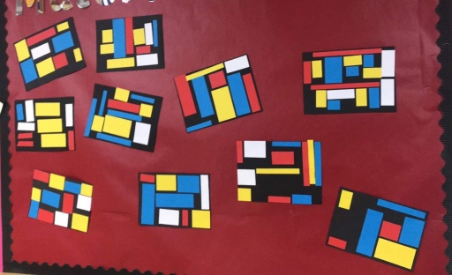
In art, we have been looking at the abstract artist Piet Mondrian and have had a go at creating our own versions of his 'Composition with Red, Blue and Yellow 1929', which look great in our classroom.

For science, we have been learning about the four seasons of the year and the months associated with them. We have used the school garden to look for signs of the season that we are in at the moment.

This week's star of the week goes to Scott who has been really brave and has come into school with a lovely smile on his face every morning this week. Very well done Scott 🌟

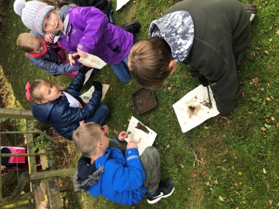
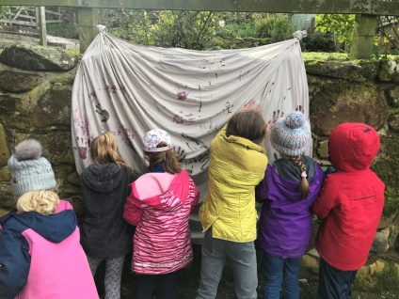
This week inKS2, the children have written an explanation text about their own inventions, designed to fight COVID-19. There was certainly some weird and wonderful inventions well explained!
In maths, the Year 3/4 children have worked with Roman numerals and rounding numbers to 10. Year 5/6 have continued with column subtraction and using inverse operations to check calculations.
The children enjoyed our outdoor learning session on the school grounds this week that linked to our history Stone Age work. They explored natural materials that could be used to create colour to paint with and we all recorded our handprints and other pictures using them on our very own ‘class cave wall’.
Star of the week this week is Daniel for some fantastic written work!

Medical Rolling Consent Form 2020/21
If you have not already done so, please complete and return the form early next week as it is very important that we have up to date medical and contact details for when pupils are off the premises during this school year. Please also remember to notify us of any changes to these details throughout the year.

PTFA
As mentioned previously, we need to appoint a new Chair for the PTFA, as well as inviting any other interested parents to join. Covid restrictions will mean this has to run slightly differently in comparison to previous years but we are sure that, through the wonders of technology, we can still raise funds and make improvements to every child’s school experience.
The level and type of commitment will depend on your availability. You don’t need any specialist skills, just a willingness to support the school. If you would be interested in joining the PTFA, please could you let us know by phoning the school or sending an email to: admin.castleton@yeat.co.uk

Sport Relief Fun Run
We are pleased to report that the total sponsor money raised from our bi-annual Sport Relief Fun Run down the gated road, back in March, was a magnificent £505.40!! Thank you all for your support and for the generous sponsorship for this worthwhile cause.

Next Week
Monday Music Lessons with Alix Lillie. Please remember instruments
Flu Immunisations 1pm
Wednesday All pupils Outdoor learning. Children can come to school dressed in appropriate clothing - lots of warm layers, with waterproofs, wellies and gloves.
Thursday PE for all pupils. Please make sure children have their PE kit in school. EYFS/KS1 to arrive in PE kit; KS2 to arrive in uniform (we will change into kit before our lesson).

