__________________________________________________________________________________________

Message from Mrs Hird
We have reached the end of our first half term and I am thrilled that the school has been able to remain open, despite the ongoing pandemic. It has been wonderful to see how well the children have settled back into school life and I am sure they will return after the break with the same enthusiasm. Whilst we hope that everyone has a good rest over the holidays, I would also love to hear that your children have been continuing with their reading, multiplication tables and spellings!

Thank you for your continued efforts with social distancing at the start and end of the school day. We have been fortunate as a school to not have been directly impacted by covid to date but must all ensure that we continue to comply with the guidance in order to keep everyone safe and reduce the risk of transmission.

Well done to everyone for their fantastic homework projects. The staff and I had a very difficult time choosing our favourites, as there were so many creative and informative pieces of learning.

Have a wonderful break and I look forward to seeing everyone back in school from Monday, 2nd November. As always, if you have any questions or queries, please feel free to get in touch.
Mrs Hird

Attendance: This week’s attendance was a fantastic 98.89% so, again, above our target of at least 97%.

News from the Classes
KS1: Wow! We can hardly believe that we have made it to half term already! The children have all been absolutely amazing and have come to school every morning with such good spirits and enthusiasm for learning and have kept us all so positive in these challenging times. It was also so lovely to hear such positivity from parents (during our rather peculiar parents’ evening) about how well adjusted and happy the children feel about our slightly different daily routines.

This week in class we have been busy practising our Harvest songs and sharing ideas about what Harvest means to us. We have a lot to be grateful for, even in these difficult times.

In Maths, Year 1 have been looking at number bonds within 10 and finding all the different possible ways of writing these as calculation sentences. Year 2 have been looking at number bonds to 10 and then 100! But they have thankfully found some patterns of similarity that make it a bit easier.
In English, we have looked at episode two of Little Red Riding Hood’s story, where we met the wolf and realised that he had a very good reason for wanting to eat the little girl. We have been sequencing events within the story so far and thinking of ways to help the wolf’s poorly nose. The EYFS children performed some fabulous role play between the wolf and a vet who had to treat his poorly nose. Some of their treatment suggestions were very imaginative!

We have also started to think about Remembrance Day, what it represents and why we remember it. The children have been very busy creating something that we can share with our community - there will be more information about this after half term when we return for more learning and outdoor adventures.

Next half term, in History sessions, we will be looking at toys. Ordinarily, we would ask the children to bring in a favourite toy from home and, if possible, a favourite toy of their parents and grandparents, to set up a toy museum. As this is not currently possible, we ask that photographs could please be brought in instead. Thank you.

This week, we have 2 Stars of the Week, Gabriella and Ella for both having a positive attitude to Maths!
KS2: Years 3 and 4 have work adding 100s, multiple of tens, then 1s and 1000s too. Years 5 and 6 have been busy tackling division of 4 digit numbers by 1 digit, some with remainders.
In English, the children have used their imaginations and creativity to compose their own adventure stories. Mrs Walley is so impressed with how they are building their writing stamina!
As part of Forest Schools and History, they thoroughly enjoyed leaving each other trails to following using sticks, stones, apples and leaves.
Our highlight this week was playing golf down on the field. The children loved having more space to “drive” and putt the ball.
Next half term, we will move onto basketball and this will be outdoors. Please ensure your child has long tracksuit bottoms, a jumper, hat, coat and gloves with them to help keep them warm!

Our Star of the Week this week is Fynn for always working hard, listening and applying her skills to better her learning.

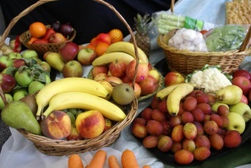
Harvest Celebration
As we have been unable to invite you all to our usual Harvest Festival in Church this year we recorded the children singing, “Harvest Time Is Here Again” and this has been posted on the School Facebook page and emailed out to some parents. If you have not seen it or been able to view it, please get in touch.

Updates on your child’s progress
We know that, as parents, you like to be kept informed about the learning your child has been accessing in school and so thought it would be useful to remind parents of the ways in which we share this information.

Parents’ evenings take place each term and are an opportunity to discuss your child’s progress and hear about the learning they have been doing.
We also make sure we include details of what each class has been learning in the weekly newsletter, as well as including updates via the Facebook group, where appropriate. Our curriculum overviews will also be sent out so you can see what learning your child will be accessing in the coming weeks.

Tapestry profiles are available for all pupils in Reception and include details of their learning activities.

Class Dojo is used to record points that pupils gain in school. This will also be used as our main method of supporting learning if we have a remote/blended learning situation.

If, at any point, you would like to know more about what your child is learning, please do contact their class teacher either via phone or email.

Facebook page
The existing Facebook group was originally set up for the PTFA and we would therefore like to set up a new, public Facebook page so that we can celebrate the school’s success and engage others within the wider community. The new site will be launched after the half term break and parental consent forms will be sent out before any pupil images are added.
The existing Facebook group will no longer be directly linked to the school and all information and messages will be sent out on the new, public site. Messages to the new site will be moderated by school staff and responded to accordingly.

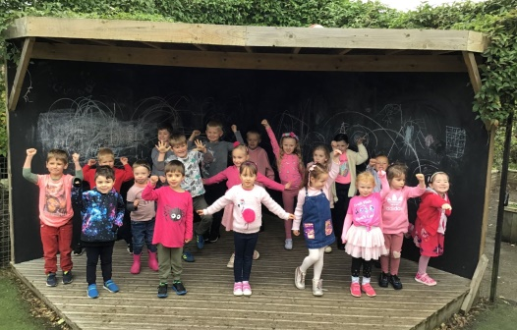
“Wear it Pink” Fundraising Day for Breast Cancer

It was lovely to see all “the pink” in school today. Your generous donations amounted to almost £92 which is fantastic for Breast Cancer Care – a very worthwhile cause.

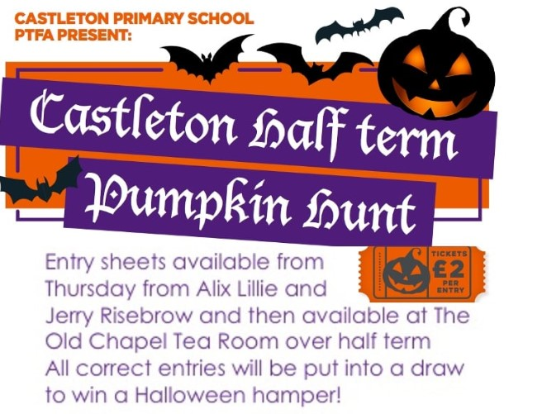

PTFA Pumpkin Hunt
Many thanks to Alix Lillie for coming up with the idea of a Pumpkin Hunt and to all the parents who are helping her with this.

Breaktime Drinks and Snacks
We will not be selling hot chocolate this year, although children will still enjoy it as an occasional treat during outdoor learning sessions. Drinks of juice or milk are still available and can be purchased via MCAS for 25p per child per day. Pupils in EYFS/KS1 receive free fruit. If children in KS2 would like to bring a piece of fruit for break time, they are welcome to do so.

“Signing and Communication” After School Club – Commencing 3rd November
The above extra-curricular club, run by Sophie Wilson, will commence on Tuesday, 3rd November. This club is open to pupils from Year 1 upwards and will run from 3.15 to 4.15pm. If your child/children would like to attend, please contact Mrs Blacklock for a permission slip, which must be completed before they can attend.

Halloween and Bonfire Night Safety
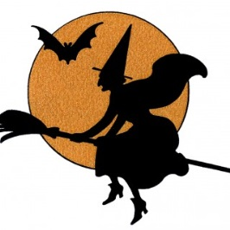
Most years we invite North Yorkshire Fire Service into school to talk to the children about Halloween and Bonfire Night Safety. As visits such as this are not currently taking place, they have asked us to pass on the following information:-

Halloween may be different this year but if you’re planning to celebrate by decorating your home please follow our tips below to help you have a spooktacularly safe time:

· Make sure you follow guidance on social distancing and restrictions on households mixing
· Consider using battery operated lights within homemade lanterns and pumpkins, they are much safer than candles
· If you are going to use candles:
  - Make sure they are secured in a proper holder and away from materials that may catch fire – like curtains or decorations
  - Children should not be left alone with lit candles. Put candles out when you leave the room, and make sure they’re put out completely at night.
  - Do not burn several candles close together as this might cause flaring
  - If you’re using plastic capes and bin bags as part of costumes, keep them away from candles and other naked flames. In the event that clothing does catch fire - remember to STOP, DROP and ROLL:
      - STOP where you are. Do not run
      - DROP to the ground. Lay flat with your legs out straight
      - Cover your eyes and mouth with your hands
      - ROLL over and over and back and forth until the flames are out
      - Get help straight away
Remember - stay safe and have fun!

We are asking everyone to show RESPECT this Bonfire Night.
Whilst most people enjoy fireworks responsibly, in the wrong hands they can cause real misery. Remember that fireworks are explosives, and as such should be treated with respect and only used in accordance with the manufacturer’s instructions and the Firework Code.
With many organised events cancelled, emergency services are preparing for a busier night than usual as people celebrate in their own gardens.
If you are thinking about organising a home display, think carefully, plan carefully and follow the Firework Code.
· Make sure you follow guidance on social distancing and restrictions on households mixing
· Plan your firework display to make it safe and enjoyable, and ensure it finishes before 11pm
· Only buy fireworks which carry the CE mark, keep them in a closed box and use them one at a time
· Read and follow the instructions on each firework using a torch if necessary
· Light the firework at arm's length with a taper and stand well back
· Keep naked flames, including cigarettes, away from fireworks
· Never return to a firework once it has been lit
· Don't put fireworks in pockets and never throw them
· Direct any rocket fireworks well away from spectators
If you’re having a bonfire:
· Check for hedgehogs and other wildlife before lighting your bonfire.
· Never use paraffin or petrol on a bonfire.
· Don’t build bonfires close to trees, hedges or sheds.
· Don’t leave bonfires unattended.
· Make sure that the bonfire is out and surroundings are made safe before leaving.

Christmas Shoebox Appeal – Children in Distress
Thursday, November 12th is the last day Jen Littlewood can hand over the completed shoe boxes. If you are hoping to do one you will need to fill in a form to stick on the box so they know what is inside and also an address form for gift aiding the £2 donation to help cover delivery costs. Please ask Jen or Mrs Blacklock for the forms. Also, every child who does a shoebox will receive a metal pin badge.

North York Moors National Park Events
Please see the enclosed leaflet detailing events taking place at The Moors Centre and Sutton Bank over half term week.

Whitby Town Council Mayoral Christmas Card Competition
Whitby Town Council is inviting children to enter the above competition and the winning design will be used as the Mayoral Christmas card, to be sent out to civic dignitaries across the world. The theme is “Festive Whitby.” The individual winner will receive a £10 book token and if the design is submitted through school we will also win a £50 book token. If your child/children would like to take part, attached is an Application Form. Please note that entries need to be delivered to Pannett Art Gallery by Tuesday, 3rd November.

Week Beginning 02.11.20
Monday Music Lessons with Alix Lillie. Please remember instruments

Tuesday Signing & Communication After School Club – finish time 4.15pm

Wednesday All pupils Outdoor learning. Children can come to school dressed in appropriate clothing - lots of warm layers, with waterproofs, wellies and gloves.

Thursday PE for all pupils. Please make sure children have their PE kit in school. EYFS/KS1 to arrive in PE kit; KS2 to arrive in uniform (we will change into kit before our lesson)

